3. DATA FLOW & SYSTEM BEHAVIOR
System Analysis & Design
Purpose: This section explains how security data moves through the SIEM-based SOC workflow, how components interact, and how alerts/incidents progress through defined states. Insert final diagrams in the clearly marked placeholders. Ensure each diagram reflects what is actually implemented or explicitly label planned/simulated components.

3.1 Data Flow Diagram (DFD)

3.1.1 Context-Level DFD (Level 0)
The system receives security telemetry from organizational sources, processes events, generates alerts, and provides investigation and response information to SOC analysts. Threat-intelligence sources and a local AI model may provide context or summaries. Response actions remain subject to authorization and human approval where appropriate.
External Entity / System | Data Sent to SIEM/SOC | Data Received / Output
Endpoint Systems (Windows/Linux) | Authentication events, system logs, process and endpoint security events | Monitoring/response status where available
Network Security Devices | Firewall, IDS/IPS, DNS, proxy and network telemetry | Investigation or blocking instructions through authorized controls, if implemented
Identity Services | Login successes/failures, account and privilege events | Account review or containment requests, if supported
Cloud / Applications | Audit events, application logs, access and security events | Investigation findings or administrative actions, if supported
Threat Intelligence Sources | IOC reputation/context for IPs, domains, URLs and hashes | IOC lookup queries
SOC Analyst | Searches, triage decisions, severity, notes, escalation and closure actions | Alerts, dashboards, enriched context, investigation records and reports
Local LLM (Ollama) | Sanitized alert details and log excerpts supplied for assistance | Draft summaries, investigation prompts and report text requiring human validation

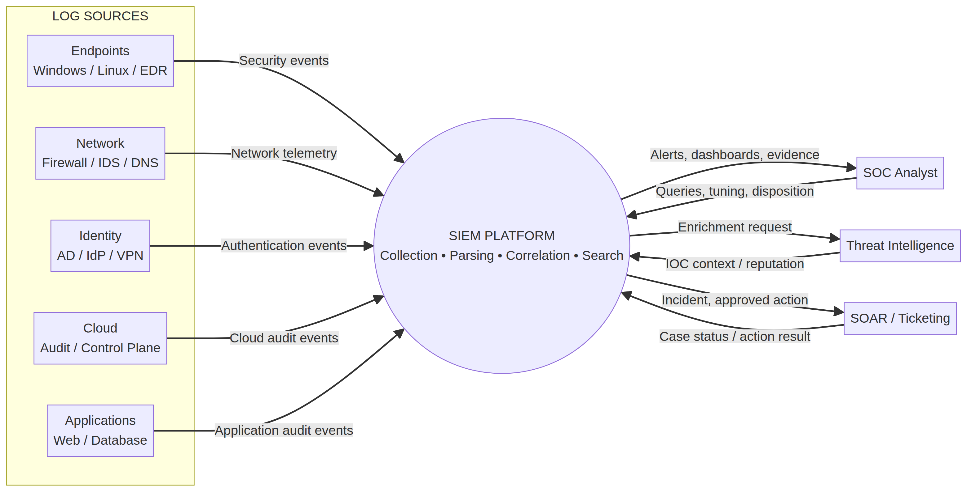

3.1.2 Detailed DFD (Level 1)
The Level 1 DFD decomposes the main system into collection, normalization, detection, triage, enrichment, response orchestration and reporting processes. The final diagram must match the data sources and integrations configured in the lab.
Process | Inputs | Processing | Outputs / Stores
P1 — Collect Security Logs | Endpoint, network, identity, cloud and application events | Receive/forward events using configured agents or integrations | Raw event records; ingestion status
P2 — Parse & Normalize | Raw event records | Parse fields and normalize timestamps, usernames, source/destination IPs, event IDs and event types where available | Normalized event records
P3 — Apply Detection Logic | Normalized events and correlation context | Evaluate threshold, sequence and behavioral conditions for brute force, suspicious login, lateral movement, persistence and data exfiltration | Detection alerts with rule ID, timestamp, severity and evidence
P4 — Triage & Investigate | Alerts, relevant logs, asset/user context | Validate alerts, assess true/false positive or inconclusive status, determine scope/severity and build a timeline | Triage record, investigation notes and escalation decision
P5 — Threat-Intelligence Enrichment | Observable IOCs: IPs, domains, URLs, hashes | Query selected sources and record result, source and lookup timestamp | Enriched alert context and IOC findings
P6 — MITRE ATT&CK Mapping | Detection behavior and investigation evidence | Map observed behavior to relevant tactics/techniques when evidence supports it | Technique mapping and coverage matrix
P7 — Response / SOAR Workflow | Validated alert, severity, analyst decision and playbook | Recommend or execute approved steps according to implemented capability and approval rules | Response records, escalation, status updates and audit trail
P8 — AI-Assisted Analysis | Selected alert details and sanitized log excerpts | Local LLM drafts summaries, investigation questions and report text | AI draft output, validation notes and corrected final text
P9 — Dashboard & Reporting | Alerts, triage records, response timestamps and case status | Aggregate alert volume, top attackers/targets, closure rate and time-based metrics | SOC dashboard, KPI views and final SOC operations report

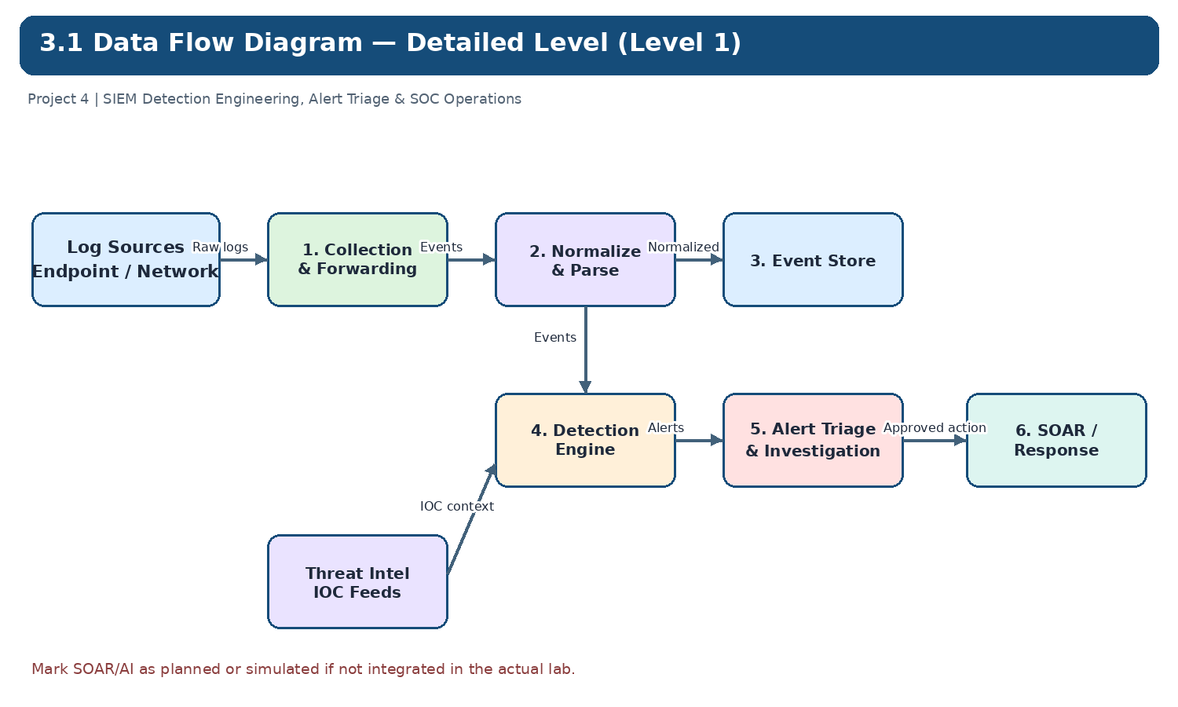

3.1.3 Logical Data Stores
Data Store | Contents | Purpose
D1 — Raw / Ingested Events | Original event payloads and ingestion metadata | Preserve source evidence and troubleshoot collection
D2 — Normalized Events | Parsed events with consistent fields | Support searches, correlation and cross-source analysis
D3 — Detection Rules & Configuration | Rule definitions, thresholds, versions and tuning notes | Track and test detection logic
D4 — Alerts / Cases | Alert IDs, severity, timestamps, status, analyst notes and disposition | Support triage, escalation, closure and metrics
D5 — IOC / Enrichment Records | IOC value/type, lookup source/result/time and analyst assessment | Preserve threat-intelligence context
D6 — Audit / Response Records | Analyst actions, approved playbook steps, results and timestamps | Support accountability and incident review

Note: These are logical data stores in the model; they do not imply separate physical databases have been deployed.

3.2 Sequence Diagrams
Sequence diagrams show time-ordered interactions between system components. Use the following steps and lifelines when drawing each diagram; align them with the tools and integrations actually implemented.

3.2.1 Sequence A — Log Ingestion and Detection
- An endpoint or network source generates a security event.
- The configured agent or log forwarder sends the event to the SIEM.
- The SIEM receives and parses the event, extracting available fields.
- The normalization step maps fields into the agreed schema where supported.
- The detection engine evaluates the event against enabled rules and correlation conditions.
- If a rule matches, the SIEM creates an alert containing a timestamp, rule reference, severity and supporting evidence.
- The alert becomes available to the SOC analyst for triage.

3.2.2 Sequence B — Alert Triage and Threat-Intelligence Enrichment
- The SOC analyst opens an alert and reviews its rule logic and supporting events.
- The analyst checks relevant endpoint, identity, network and asset context available in the lab.
- Observable IOCs are submitted to selected threat-intelligence sources if lookup is available.
- The analyst records the source, timestamp and result of each lookup.
- The analyst determines disposition (true positive, false positive or inconclusive), then updates severity and scope.
- The analyst escalates the case or closes it according to the documented triage procedure.

3.2.3 Sequence C — AI-Assisted Investigation and SOAR Response
- The analyst selects relevant alert fields and sanitized evidence for AI-assisted analysis.
- The local LLM receives the supplied context and returns a draft summary, investigation prompts or report text.
- The analyst verifies material claims against original logs, alert evidence and trusted sources.
- The analyst updates the case with validated findings and selects an approved response playbook.
- The playbook presents or performs only actions supported by implemented integrations and approval policy.
- The system or analyst records response results, timestamps, errors and final case status.
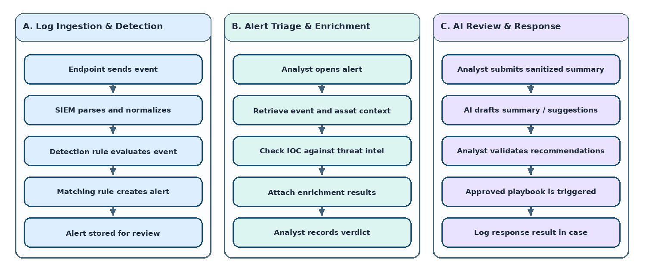

3.3 Activity Diagram
The activity diagram represents the end-to-end SOC workflow, with decision points for alert validation, escalation and response. It should distinguish automated processing from analyst decisions.
- Start: a monitored source generates a security event.
- Collect, parse and normalize the event.
- Evaluate the event against enabled detection rules.
- Decision: Does the event match a rule? If no, retain/search it according to lab configuration; if yes, create an alert.
- The analyst performs initial triage and validates the alert.
- Decision: True positive, false positive or inconclusive? Record the rationale and handle accordingly.
- For a potentially valid incident, determine severity and scope; enrich relevant IOCs and map behavior to MITRE ATT&CK when evidence supports it.
- Decision: Is escalation or containment required? Follow the playbook and approval requirements.
- Perform or recommend response actions available in the lab; record outcomes.
- Use AI assistance for drafts and investigation prompts only; validate output against evidence.
- Update the case, dashboard and report; close or continue monitoring according to defined criteria.
- End: findings and lessons learned are documented.
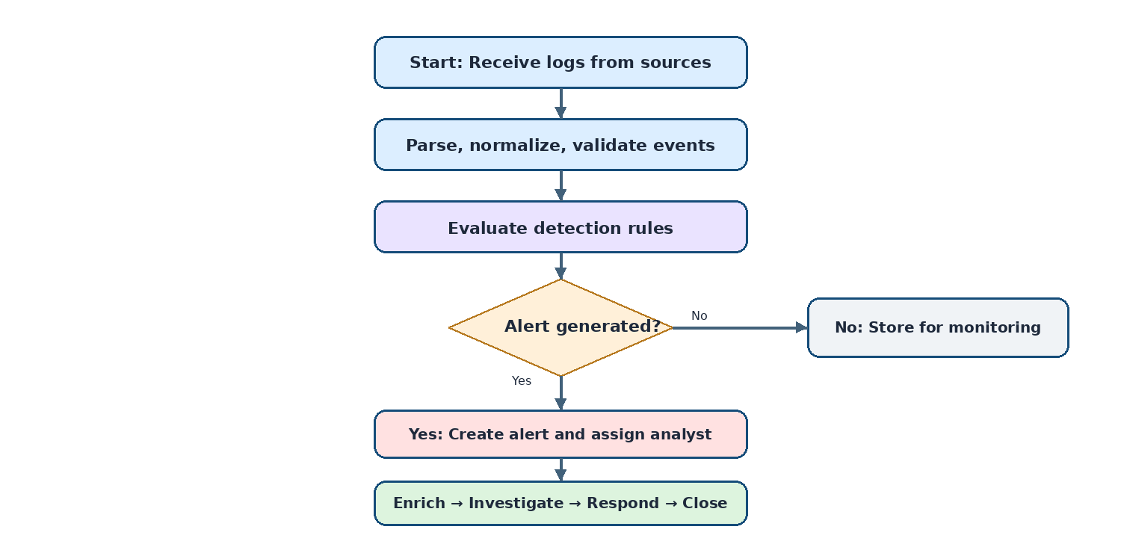

3.4 State Diagram
The state diagram models the lifecycle of a SIEM alert/case. These are proposed logical states; use equivalent native statuses if the selected SIEM or case-management tool uses different terminology.
State | Meaning | Typical Transition / Trigger
New | Alert created but not reviewed | An enabled detection rule generates an alert
Assigned | An analyst/team accepts ownership | Assignment or ownership is recorded
Under Investigation | Evidence and context are being reviewed | Triage begins and relevant logs/assets are examined
Enrichment Pending | Additional IOC or asset context is needed | Analyst requests threat-intelligence lookup or supporting data
Escalated | Case requires a higher tier, incident lead or authorized decision-maker | Impact, severity or uncertainty exceeds analyst authority
Containment / Response | Approved response actions are being performed/coordinated | Response plan is approved and initiated
Resolved | Investigation/response objective has been met, pending closure checks if required | Evidence and response results are reviewed
Closed | Case closed with disposition and documentation | Closure criteria and required notes are complete
Reopened | New evidence or recurring activity requires further investigation | Relevant new evidence/activity appears after closure

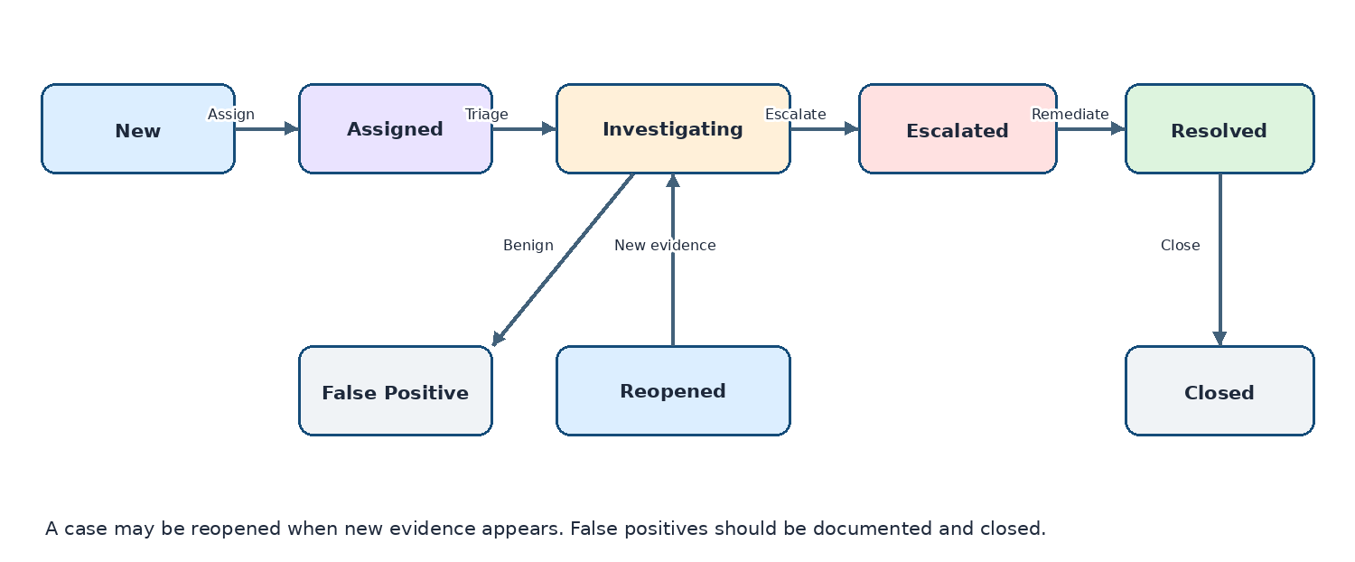

3.5 Class Diagram
The class diagram describes the main logical entities for the SOC workflow. This is a conceptual model and does not prescribe a specific programming language or physical database.
Class | Example Attributes | Relationships / Operations
LogEvent | event_id, timestamp, source_type, host, username, src_ip, dst_ip, event_type, raw_payload | Normalized into NormalizedEvent; may provide evidence for alerts
NormalizedEvent | normalized_event_id, timestamp, user, source_ip, destination_ip, action, outcome, severity, original_event_id | Used by DetectionRule; linked to source LogEvent
DetectionRule | rule_id, name, description, logic_type, threshold, severity, enabled, mitre_technique_id | Evaluates NormalizedEvents and may generate Alerts
Alert | alert_id, created_at, rule_id, severity, status, summary, disposition | Generated by DetectionRule; reviewed by Analyst; linked to IOC/Case
Case | case_id, title, priority, status, assigned_to, opened_at, closed_at, impact_summary | Groups related alerts, evidence and response actions
Analyst | analyst_id, role, team, permission_level | Performs triage, records decisions, approves permitted actions and closes cases
IOC | ioc_id, value, type, source, reputation, first_seen, last_seen, lookup_time | Enriches alerts/cases; linked to threat-intelligence results
MitreTechnique | technique_id, name, tactic, mapping_rationale | Linked to detections/cases when evidence supports the mapping
Playbook | playbook_id, name, trigger, approval_required, actions, version | Invoked for a validated case; may produce ResponseAction records
ResponseAction | action_id, case_id, action_type, requested_by, approved_by, status, timestamp, result | Belongs to a Case and records response outcomes
AIAnalysis | analysis_id, model_name, prompt_version, input_reference, draft_output, validation_status, reviewer | Draft assistance linked to an Alert/Case; requires analyst validation

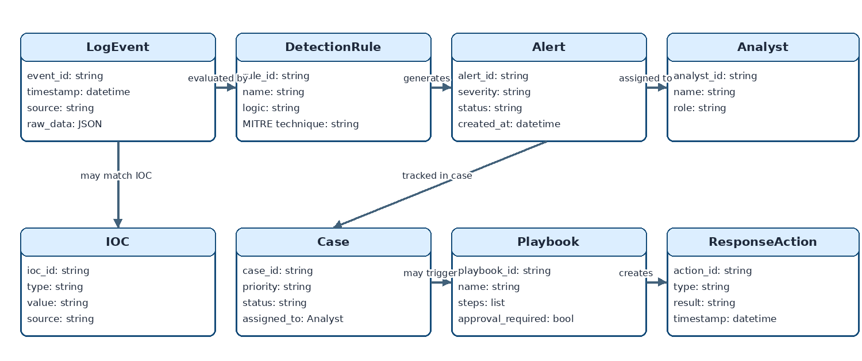

3.6 Consistency and Validation Notes
- Use consistent names for actors, processes, data stores and components across all diagrams.
- Show only data sources and integrations that are implemented; clearly label planned or simulated components.
- Use labeled arrows for data flows in DFDs; do not confuse data movement with control-flow steps.
- Keep alert/case states consistent across the activity, state and sequence diagrams and the triage procedure.
- Define MTTD/MTTR start and end timestamps explicitly and calculate metrics only from available, reliable timestamps.
- Record threat-intelligence source and lookup time; IOC reputation alone is not proof of compromise.
- Treat AI output as a draft and validate findings against original evidence before recording them.
- Document whether SOAR actions are automated, simulated or analyst-executed, and include approval gates for disruptive actions.

Appendix — Diagram Checklist
Diagram | Minimum Content | Status
DFD Level 0 | External entities, main SIEM/SOC process, major input/output flows | To be inserted
DFD Level 1 | Collection, normalization, detection, triage, enrichment, response, AI/reporting processes and logical stores | To be inserted
Sequence A | Source → agent/forwarder → SIEM parser/normalizer → detection engine → alert | To be inserted
Sequence B | Analyst → alert → log/asset context → TI lookup → disposition/escalation | To be inserted
Sequence C | Analyst → local LLM → validation → approved playbook → recorded response | To be inserted
Activity Diagram | End-to-end workflow with decision branches | To be inserted
State Diagram | Alert/case states and transition triggers | To be inserted
Class Diagram | Core entities, attributes and relationships | To be inserted

